How to Navigate the Project

- Click on the Sign In button and login to the site.
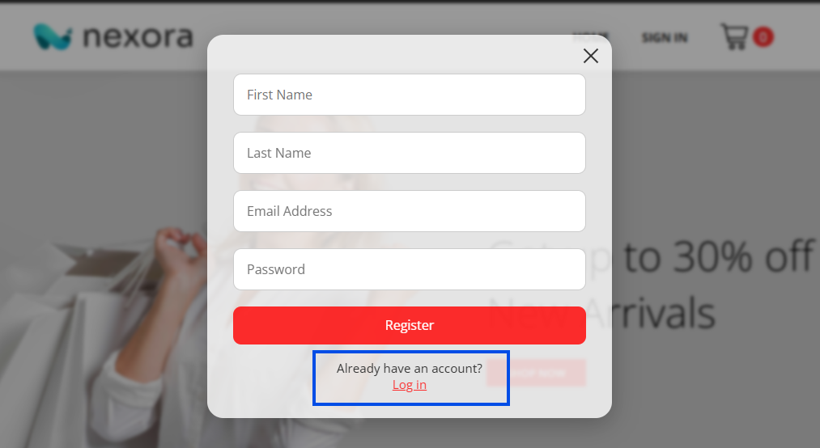

- Enter the below credentials to login and you will be redirected to dashboard.
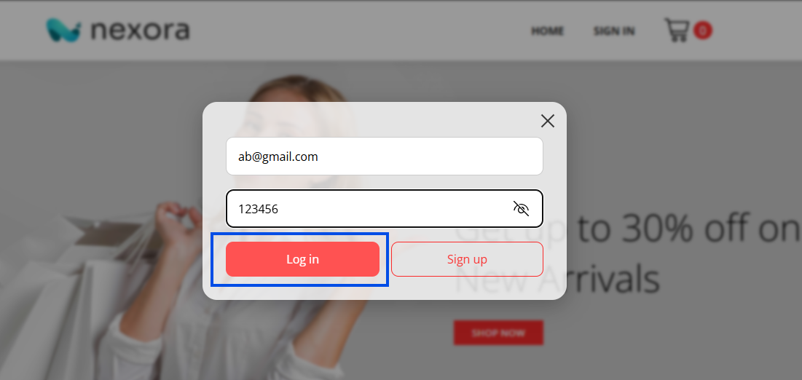
- Scroll down to check out all the products fetching from a dummy api.


- You can search for any keywords and add the items to cart. Once you add the item to cart the total number of cart items will be updated.
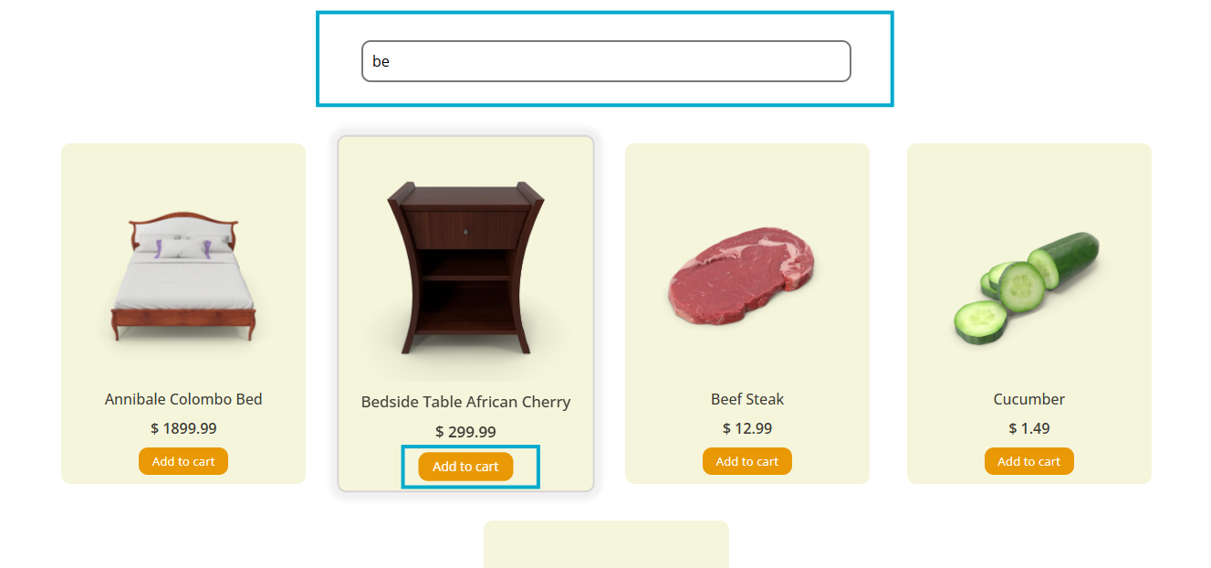

5. You can select any item to visit the product details page, here you can add the item to cart too.
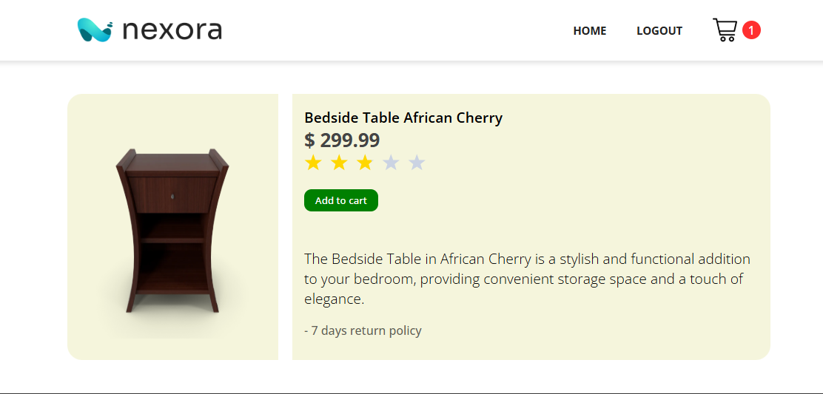

- You can decrease or increase the quantity of the cart items and the total amount will be updated automatically. You can also remove the items that you don’t want in your cart.
